LAB – 2
PYTHON BASIC PRACTICE – II

$ python3 e1.py
Name Age
0 Dinesh 10
1 Nithya 12
2 Raji 13
P5407@dblab-cp3

$ python3 e1.py
A B C
0 2013-01-02 3 Male
1 2013-01-02 3 Female
2 2013-01-02 3 Male
3 2013-01-02 3 Female

$ python3 e1.py
Name Age
rank1 Kavitha 28
rank2 Sudha 34
rank3 Raju 29
rank4 Vignesh 42

0 SNo ObservationDate Province/State ... Confirmed Deaths Recovered
1 1 1/22/2020 Anhui ... 1 0 0
2 2 1/22/2020 Beijing ... 14 0 0
3 3 1/22/2020 Chongqing ... 6 0 0
4 4 1/22/2020 Fujian ... 1 0 0

import pandas as pd
import numpy as np

dates=pd.date_range('20130101', periods=100)
df = pd.DataFrame(np.random.randn(100,4), index=dates, columns=list('ABCD'))

#To view first 5 records
print(df.head())

#To view last 5 records
print(df.tail())

#To view the index
print(df.index)

#To view the column names
print(df.columns)

#To transpose the df
print(df.T)

#Sorting by Axis
print(df.sort_index(axis=1, ascending=False))

#Sorting by Values
print(df.sort_values(by='B'))

import pandas as pd
import numpy as np

dates=pd.date_range('20130101', periods=100)
df = pd.DataFrame(np.random.randn(100,4), index=dates, columns=list('ABCD'))

#Slicing the rows
print(df[0:3])

#Slicing with index name
print(df['20130105':'20130110'])

#Slicing with row and column index (like 2D Matrix)
print(df.iloc[0]) #will fetch entire 1st row

print(df.iloc[0,:2]) #will fetch 1st row, first 2 columns
print(df.iloc[0,0]) #will fetch 1st row, 1st column element (single element)

#Selecting a single column
print(df['A']) #which yields a Series

#Selecting more than one column
print(df[['A','B']]) #entire 2 columns

#Selecting more than one column, with selected number of records
print(df[['A','B']][:5]) #first 5 records
#[OR]
print(df.loc['20130101':'20130105',['A','B']][:5]) #first 5 records

Output :

$ python3 e1.py
A B C D
2013-01-01 -0.640257 -0.734813 -1.596912 -0.569089
2013-01-02 0.648021 -0.568242 -1.385367 -0.473036
2013-01-03 -0.033030 1.442184 0.785498 2.137643
A B C D
2013-01-05 1.160498 -0.055084 -0.612662 -0.798652
2013-01-06 -0.237564 1.418924 -0.617713 -0.873556
2013-01-07 0.149978 -0.734223 1.101950 -0.348205
2013-01-08 0.180289 -3.839674 -0.399376 -1.444597
2013-01-09 1.716462 0.534259 1.137937 -0.523261
2013-01-10 0.442907 0.921066 0.061324 0.008391
A -0.640257
B -0.734813
C -1.596912
D -0.569089
Name: 2013-01-01 00:00:00, dtype: float64
A -0.640257
B -0.734813
Name: 2013-01-01 00:00:00, dtype: float64
-0.640256913754379
2013-01-01 -0.640257
2013-01-02 0.648021
2013-01-03 -0.033030
2013-01-04 -0.646749
2013-01-05 1.160498
...
2013-04-06 0.122258
2013-04-07 -0.288589
2013-04-08 -2.028705
2013-04-09 1.661707
2013-04-10 1.016043
Freq: D, Name: A, Length: 100, dtype: float64
A B
2013-01-01 -0.640257 -0.734813
2013-01-02 0.648021 -0.568242
2013-01-03 -0.033030 1.442184
2013-01-04 -0.646749 -1.166910
2013-01-05 1.160498 -0.055084
... ... ...
2013-04-06 0.122258 -0.077409
2013-04-07 -0.288589 0.535224
2013-04-08 -2.028705 -1.354978
2013-04-09 1.661707 -0.726852
2013-04-10 1.016043 0.265876

[100 rows x 2 columns]
A B
2013-01-01 -0.640257 -0.734813
2013-01-02 0.648021 -0.568242
2013-01-03 -0.033030 1.442184
2013-01-04 -0.646749 -1.166910
2013-01-05 1.160498 -0.055084
A B
2013-01-01 -0.640257 -0.734813
2013-01-02 0.648021 -0.568242
2013-01-03 -0.033030 1.442184
2013-01-04 -0.646749 -1.166910
2013-01-05 1.160498 -0.055084

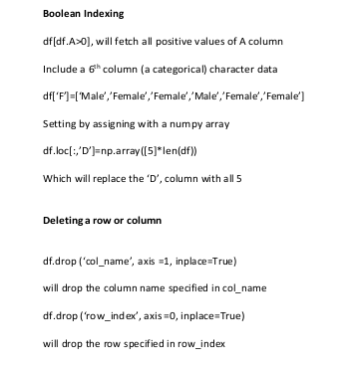

5
import pandas as pd
import numpy as np

# Concatenating DataFrames along columns (axis=1)
df1 = pd.DataFrame(index=range(10), columns=range(5))
df2 = pd.DataFrame(index=range(10), columns=range(3))

Df_new = pd.concat([df1, df2], axis=1)
print(Df_new.shape)

# Concatenating DataFrames along rows (axis=0)
A = pd.DataFrame(index=range(10), columns=range(5))
B = pd.DataFrame(index=range(15), columns=range(5))

D = pd.concat([A, B], axis=0)
print(D.shape)

6)
import pandas as pd
import numpy as np
import matplotlib.pyplot as plt

# Reading a CSV file & XLS file format
df = pd.read_csv('xyz.csv',header=None)
df.head() #This will display 1 st 5 records
df.tail() #This will display last 5 records

#The above dataset doesn’t have header, we shall attach our own header.
df.columns=['preg','glu','bp','sft','ins','bmi','dpf','age','class']
#Let us visualize the scatter plot of two continuous variable.
#plt.scatter(df['bmi'],df['glu'])
#df['age'].hist()
plt.boxplot(df['age'])
plt.hist(df['age'])
plt.xlabel('bmi')
plt.ylabel('Glucose')
plt.show()

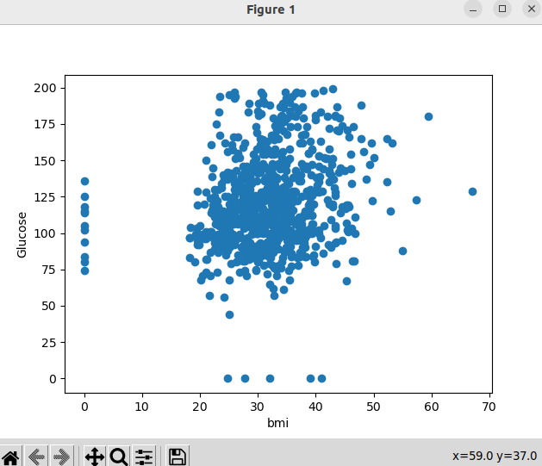

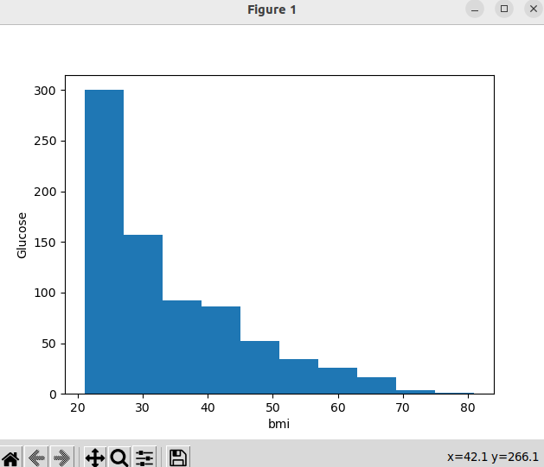

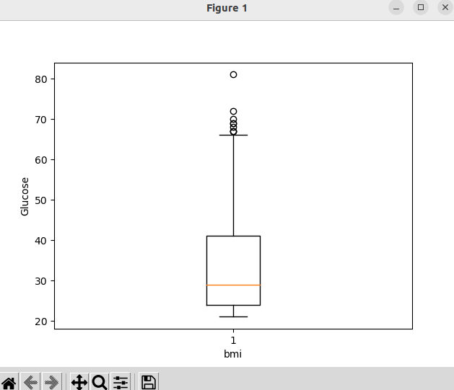

import pandas as pd
import numpy as np
import matplotlib.pyplot as plt

H = pd.read_table('HR.txt')
print(H.head())

#f=H['Department'].value_counts()
#print(f)

#f.plot(kind='bar')
#f.plot(kind='pie')
fa=pd.crosstab(H['Gender'],H['Attrition'])
fa.plot(kind='bar')

plt.show()

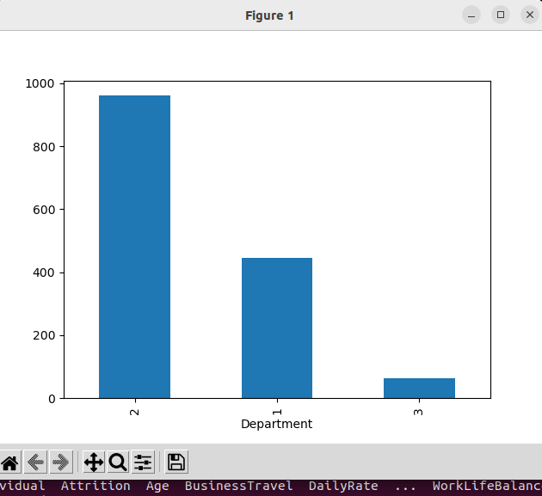

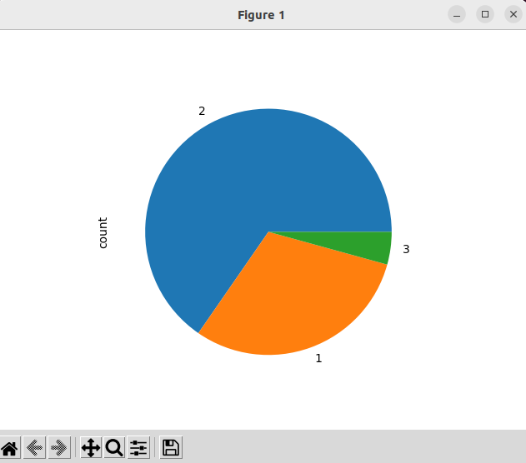
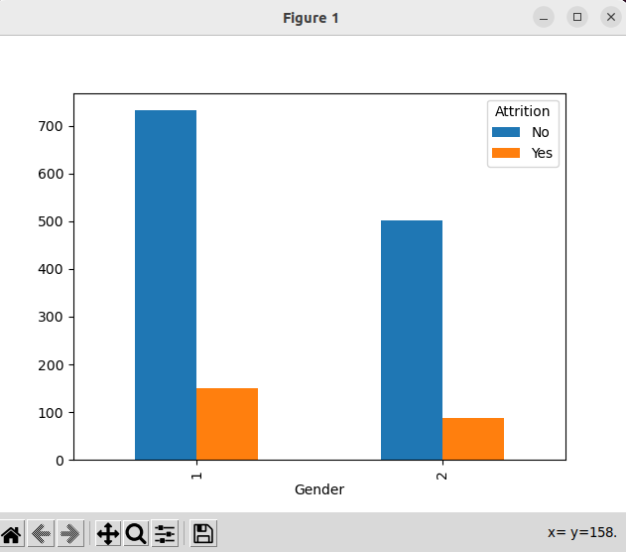

import pandas as pd
import numpy as np
import matplotlib.pyplot as plt

H = pd.read_table('HR.txt')
print(H.head())

#f=H['Department'].value_counts()
#print(f)
B = pd.read_html('Test runs-1.html')
print(B)

Individual Attrition ... YearsSinceLastPromotion YearsWithCurrManager
0 Ind1 Yes ... 0 5
1 Ind2 No ... 1 7
2 Ind3 Yes ... 0 0
3 Ind4 No ... 3 0
4 Ind5 No ... 2 2

